Face Recognition with Viola Jones Algorithm

Contents
1. Introduction 4
2. What exactly is “face detection”? 4
3. How do computers “see” images 5
4. What are “features” 6
5. Viola Jones Object Detection Framework 7
5.1 The Haar-like Features 7
5.2 The Integral Images 9
5.3 The Adaptive Boosting (AdaBoost) 11
5.4 The Cascading Classifiers 14
5.5 Using the Viola-Jones Classifier 15

Introduction

For quite some time not “computer vision” started to become an exciting field which started to draw attention more and more. Of course, there are many interesting problems in this field. One such problem is called “face detection”. This is the computer’s ability to determine that an image contains a human face and mark its position in the image.
In all this computer vision work it is useful to know / understand how such a machine “sees” images, how are these represented inside it and how one object differs from any other object.
This tutorial is based on the one available here: https://realpython.com/traditional-face-detection-python/. This tutorial’s purpose is to search answers related to the following questions:
- What exactly is “face detection”,
- How computers understand features in images,
- How to quickly analyze many different features in images,
- How to use a minimal Python solution for detecting human faces in images.

What exactly is “face detection”?

“Face detection” is a technology that allows the computer to detect people’s faces in digitally represented images. After detection, the computer is able to detect its position. One can easily think that in this images are many objects (like cars, buildings, trees, roads, etc.) and also many people.

“Facial analysis” tries to understand something about people using their facial features. This includes age, gender, and even emotion determination.

“Facial tracking” uses a video sequence to try to track a human face in the images presented in video. Some of the most popular application are various filters like “Snapchat”.

This tutorial will focus on a solution to detect the human face.

How do computers “see” images

The smallest image element is called a “pixel”. This is a “dot” in the picture. An image is formed using many pixels arranged on rows and columns.
In BW images, a pixel will be represented as a grey (white and black are also gray levels). There are 256 levels of gray (0 being black while 255 being white). A number representing its gray level is assigned to each pixel. As such, a pixel may be transmitted just by sending the number representing its gray level. In this case, the image is a matrix of numbers (one for each pixel) as shown in figure 3.1.

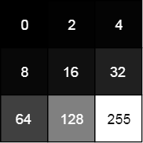
Fig. 3.1: A BW sample image

In color images case, each pixel is often represented using three colors: Red, Green, Blue. Each pixel is a mix (a weighted sum) of the three colors. Since the computer understands numbers, it helps representing every pixel is represented by three numbers. This way, the computer can easily operate with images. Since every pixel is weighted sum of three values, one can consider a color image as three matrices (one for red, one for green and one for blue). Such a construction is called a “tensor”.

What are “features”

An image “feature” is a piece of information in the image which is considered relevant for a solution to a certain problem. A feature can be a simple pixel value, a group of pixels like edges or corners and shapes. Such simple features can be combined into a “complex feature”.
One way to extract certain features from an image is applying feature extracting operations on it.

Viola Jones Object Detection Framework

The code for face detection using the Viola Jones algorithm uses three libraries:
- Scikit-learn,
- Scikit-image,
- Opencv

The algorithm developed by Paul Viola and Michael Jones is basically a framework able to provide competitive object detection in real time. Their algorithm is composed of the following four main steps:
- Selecting Haar-like features,
- Creating an integral image,
- Running the AdaBoost training,
- Creating the classifier cascade.

Given an image, the algorithm looks at many smaller sub-regions trying to find a face by looking for specific features in each sub-region. It also needs to check many different positions and scales because an image can contain many faces of various sizes.

The Haar-like Features

Human faces have some similarities. For example, the eye region is darker than the cheeks or the bridge of the nose. These properties can be used to detect a human face in the image.
One simple way to find out if a region has is darker or lighter is to sum up the pixels in these regions and compare the results. It is easy to see that the sum of pixel values in the darker region is lower than the sum in the lighter region. This can be accomplished by the “Haar-like features”.

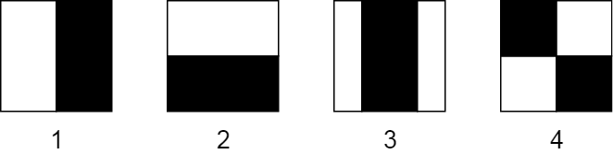
Fig. 5.1: Haar-like features

A “Haar-like feature” is represented by taking a rectangular part of an image and dividing it into multiple parts. These are often visualized as black and white adjacent rectangles (figure 5.1). In this image, one can see four basic types of Haar-like features:
- Horizontal feature with two rectangles (1),
- Vertical feature with two rectangles (2),
- Vertical feature with three rectangles (3),
- Diagonal feature with four rectangles.


Fig. 5.2: Haar-like features used for human face detection

One can easy see that the first Haar-like feature is useful to detect vertical edges, while the second one can be used to detect horizontal edges. The third feature can be used to detect lines while the fourth one can detect diagonal features.


Fig. 5.3: Haar-like features used for human face detection

The value of the feature is computed as a single number: the sum of the pixels in the black area minus the sum of the pixels in the white area. For uniform areas the result is close to zero and this does not offer a meaningful information.
To be useful, a Haar-like feature needs to give one a large number, meaning that the areas in the black and white rectangles are very different. There are known features that perform very well to detect human faces.
In the example shown in figure 5.2 one can see that the eye region is darker than the region below. One can use this property to find which areas of an image give a strong response (large number) for a specific feature.
This examples give a strong response when applied to the bridge of the nose. One can combine these many features to understand if an image contains a human face.
As mentioned, the Viola-Jones algorithm calculates a lot of these features in many sub-regions of the image. The amount of computation quickly becomes prohibitive. To address this problem, Viola and Jones use integral images.

The Integral Images

An “integral image”, also known as “summed-area table” is the name of both a “data structure” and an “algorithm” to obtain this data structure. The algorithm is used to compute the sum of pixel values in an image or a n image part.
In an “integral image” the value of each pixel is the sum of all the pixels above and to the left including the target pixel as shown in figure 5.4.

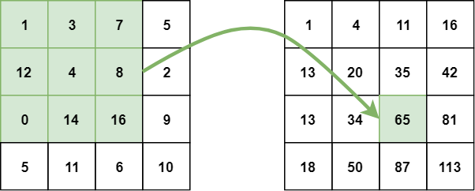
Fig. 5.4: The “integral image”

The integral image can be calculated in a single step over the original image. This reduces summing the pixel intensities within a rectangle into three operations with four numbers regardless of its size (figure 5.5).

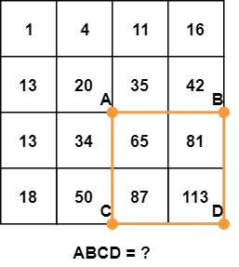
Fig. 5.5: Computing the sum of pixels in the orange rectangle

The sum of pixels in the rectangle ABCD can be derived from the value points A, B, C and D using the formula:

$${sum}_{ABCD}=D-B-C+A$$

This formula is easier to understand visually (figure 5.6).

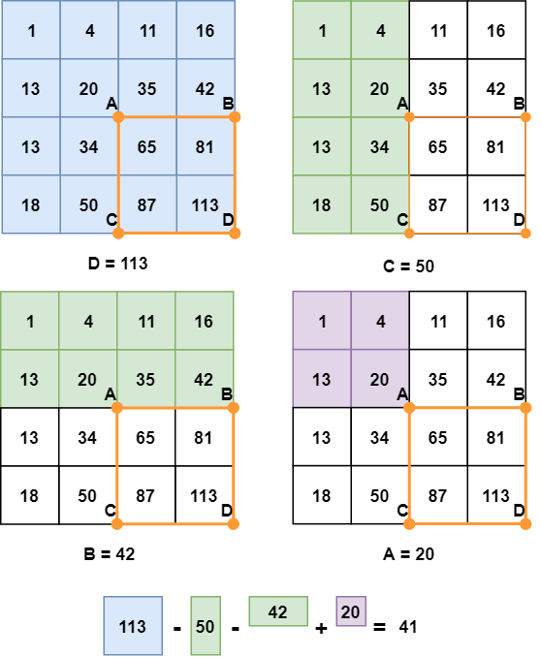
Fig. 5.6: Computing the sum of pixels in the orange rectangle

The above, is easy to see that subtracting both B and C means that the area defined with point A has been subtracted twice, so the need to be added back. This is a fast and simple way to compute the sum of pixels in a rectangle (as needed by the Haar-like features).
However, there is a need to decide the which of these features and in what sizes to be used to find faces in the image(s). This is solved by a machine earning algorithms called “boosting”. An algorithm called AdaBoost (this stands for “Adaptive Boosting”) is going to be used to address this purpose.

The Adaptive Boosting (AdaBoost)

AdaBoost uses a set of “weak classifiers / learner” to create a “strong overall classifier”. A “weak classifier” is define as one that is slightly better than random guessing.
In “face detection” that means that a weak learner can classify a sub-region of an image as a “face” or “not-face” slightly better that random guessing. A strong learner is significantly better at distinguishing “faces” from “non-faces” in an image. The boosting power comes from combining many weak classifiers (thousands) into a single strong overall classifier.

NOTE: In the Viola-Jones algorithm, each Haar-like feature represents a weak learner.

To decide the type and size of a feature that goes into the final classifier, AdaBoost checks the performance of all supplied classifiers.
To calculate the performance of a classifier, one evaluates it on all sub-regions of all the images used for training. Some sub-regions will produce a strong response in the classifier. These are going to be classified as “positives”, meaning the classifier thinks they contain a human face. Sub-regions that do not produce a strong response shall be classified as “negative”, meaning that the classifier does not think there is a human face in there.
The classifiers performing well are given importance, or weight in the final decision. The final result is a strong classifier, called “boosted classifier” or “overall classifier”. It contains the best-performing weak-classifiers.

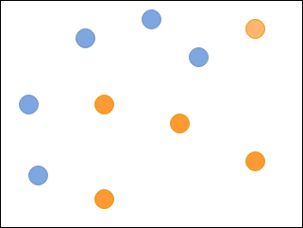
Fig. 5.7: Orange and blue points belong to difference categories

This algorithm is called “adaptive” because as training progresses, the weights of misclassified images increases. Also, at each training round, a “Best Weak Classifier – BWC” is selected. The weights of BWC is increased.
An AdaBoost example can be seen in figure 5.7. In this example is needed a classifier that correctly classifies all the blue and orange dots. One weak classifier can be seen in figure 5.8. It classifies some of the blue dots correctly but misclassified the others.

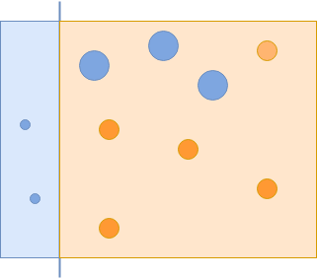
Fig. 5.8: An example of weak classifier

A second weak classifier can be seen in figure 5.9. It misclassifies some of the orange points but it correctly classifies the blue ones.

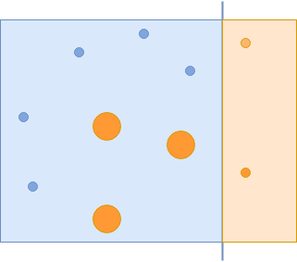
Fig. 5.9: An example of weak classifier

A third weak classifier can be seen in figure 5.10.

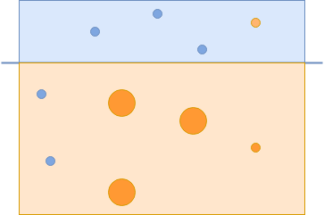
Fig. 5.9: An example of weak classifier

To create a strong classifier, one shall combine the all three classifiers to correctly classify all the points (figure 5.10).
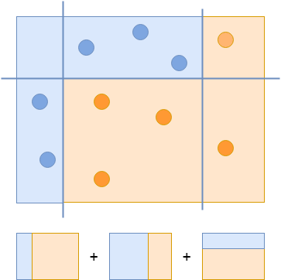
Fig. 5.10: An example of weak classifier

Using a variation of this process, Viola and Jones have evaluated hundreds of thousands of weak classifiers the specializes in finding faces in images. However, it would be computationally expensive to run all these classifiers on every region in every image. AS such, they have created a structure called a “classifier cascade”.

The Cascading Classifiers

The definition of a cascade is a series of waterfalls coming one after another. A similar concept is used in computer science to solve a complex problem with simple unite.
Here, the problem is reducing the number of computations for each image. To solve it, Viola and Jones turned their strong classifier (consisting of hundreds of thousands of weak classifiers) into a cascade where each classifier represents one stage. The job of the cascade is to quickly discard the non-faces therefore, avoid wasting time and computations.

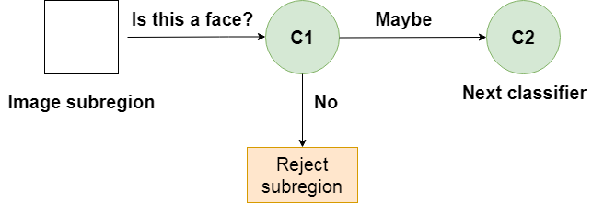
Fig. 5.11: A classifier in the cascade

When a sub-region gets a “maybe” it is sent to the next stage of the cascade. If the second stage gives a “maybe”, the sub-region gets sent to the third stage of the cascade. This mode of operation can be seen in figure 5.11.
The process described above is repeated until the image sub-region passes through all the stages of the cascade. If all the classifiers in the cascade approve it, the image sub-region is classified as a human face and it is presented as a detection.

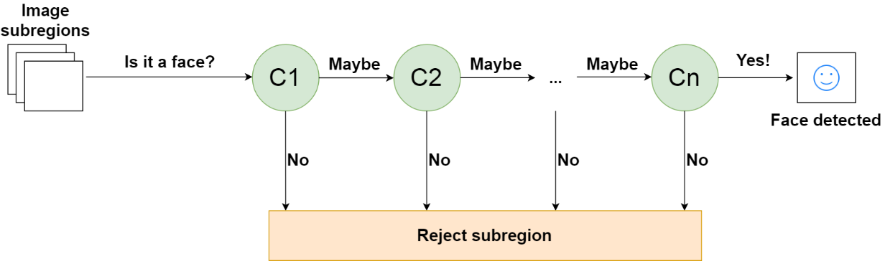
Fig. 5.11: A cascade of “n” classifiers

If, however, one cascade stage gives (it does not matter which one) a negative evaluation, the image sub-region is discarded. As such, the image sub-regions can get discarded at any stage of the cascade. This can be seen in figure 5.12.
This algorithm is designed such that the “non-faces” are discarded immediately. To accomplish this, it is important to include in the cascade the best performing classifiers as early as possible (the first stages).
NOTE: In the Viola-Jones algorithm the eyes and the nose classifiers are examples of the best weak classifiers.

Using the Viola-Jones Classifier

Training a Viola-Jones classifier from scratch can take a long time. Fortunately, a pre-trained Viola-Jones classifier comes out-of-the-box with “OpenCV”. This is easier to use and assess its performance.

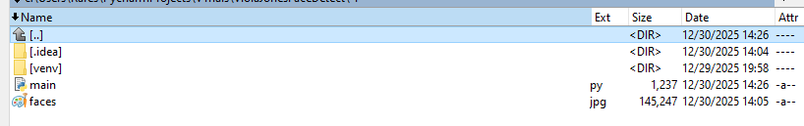
Fig. 5.12: The image (titled “faces”) needed face detection in the project’s folder

The first step is to install the libraries mentioned in the beginning of this paragraph. This is done using the following lines of code:

import skimage as skl
import sklearn as sklrn
import cv2 as cv

The second step is to load in the project the image in which face detection is desired. One can place it in the project folder as it can be seen in figure If the image is a color one, it shall be converted to BW. This is done using the following lines of code:

# convert the image to grayscale for Viola-Jones
gray_image = cv.cvtColor(open_image('./faces.jpg'), cv.COLOR_BGR2GRAY)

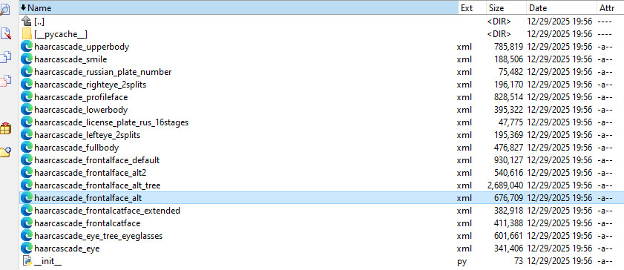
Fig. 5.13: A cascade of “n” classifiers

In the next step, one shall load the Viola-Jones from OpenCV. This is located in the same folder as the OpenCV. The path may vary depending on the version, however, the folder does contain multiple files. The needed one is called “haarcascade_frontalface_alt.xml”. This can be seen in figure 5.13. The classifier is loaded using the following line of code:
# load the Viola-Jones classifier for face detection
face_cascade = cv.CascadeClassifier(cv.data.haarcascades + 'haarcascade_frontalface_default.xml')

The object defined above and called “face_cascade” has a method called “detectMultiScale()” which receives an image as a parameter (argument) and runs the classifier cascade over the image. The term “MultiScale” indicates that the algorithm, looks at image sub-regions to detect faces of varying sizes:

# detect faces in the image
detected_faces = face_cascade.detectMultiScale(gray_image, scaleFactor=1.1, minNeighbors=5)

The variable called “detected_faces” contains the detectors for the target image. To visualize the detected faces, one shall iterate over these:

# show the faces in the image
for (x, y, w, h) in detected_faces:
cv.rectangle(original_image, (x, y), (x + w, y + h), (255, 255, 0), 2)
cv.imshow('Detected Faces', original_image)

cv.waitKey(0)
cv.destroyAllWindows()

